**2.4 IP addressing**

**Name _____________ class______________**

Access to World Wide Web content uses IP addressing.

**(a)** State what IP stands for.

__________________________________________________________________

**(b)** The following table shows four possible IP addresses.

Indicate for each IP address whether it is valid or invalid and give a reason.

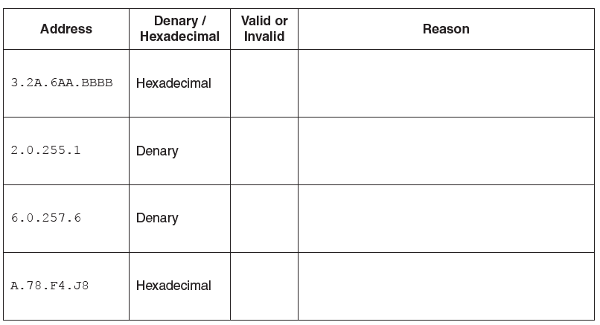

**(c)** Describe **two** differences between public and private IP addresses.

__________________________________________________________________

__________________________________________________________________

__________________________________________________________________

__________________________________________________________________

__________________________________________________________________

__________________________________________________________________

__________________________________________________________________

1. Internet Protocol

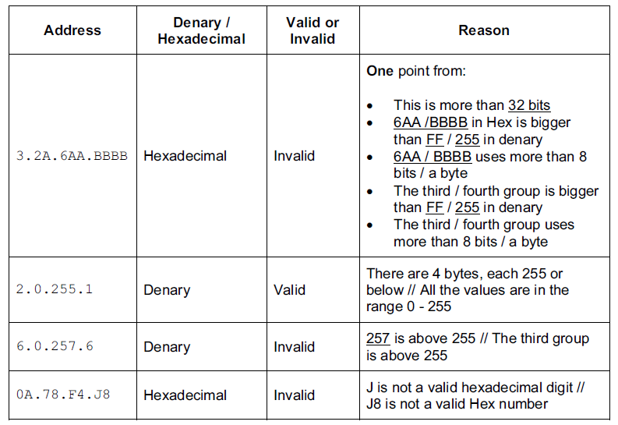

(c)

• Public address can be reached across the Internet.

• Private address can only be reached internally/through the LAN/Intranet // private

address cannot be reached across the Internet.

• NAT (Network Address Translation) is necessary for a private IP address to access the Internet directly.

• A private address is more secure than a public address // A public address is less secure than a private address.

• Public addresses are provided by ISP // Private addresses are assigned by the router (of the network concerned).

• Public addresses are unique (to the Internet) // Private addresses (are unique within their network, but) can be duplicated within other (discrete) networks.

• 10.0.0.1 to 10.255.255.254 and 172.16.0.1 to 172.31.255.254 and 192.168.0.1.to

192.168.255.254 form the private address space // IP addresses from the private address space are never assigned as public.